Object: Project | TCode: ZSTKTRK_1307
Program: | Plant: 1307
Document Version: 0 | Created By: Md Azharuddin
Date: 06.06.2025 | IT Support Portal: JINDAL/2025/SAP/614542
ABAPer Assigned:

Objective: To Extract the Change History of the Status Field of Materials in batches. This report will help to track all status changes made for the batches of the materials.
Detailed Description: The report should display all the relevant records where the batch status has changed. This will be used to track all changes in the status of batches of the material.
Input Screen:
Input Parameters: | Fields | Range (Single/Multiple)
Input Parameters: | Material Number | Multiple
Input Parameters: | Plant | Single - Fixed (1307)
Input Parameters: | Batch | Multiple
Input Parameters: | Production Order | Multiple
Selection Screen Layout: | 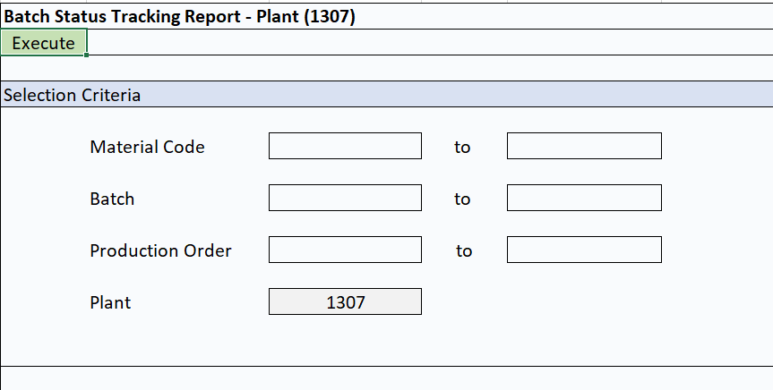

Table to Use:
MSEG, MCH1, INOB, AUSP, KSML, CABN, KSSK, KLAH, CDHDR, CDPOS, QPCT
Logic:
- Fetch records from MSEG using the following filters:
Pass MSEG – MATNR (Material Code)
MSEG – WERKS (Plant = ‘1307’)
MSEG – CHARG (Batch)
MSEG – AUFNR (Production Order) if Blank, then should not be NULL
MSEG – BWART (Movement Type = ‘101’)

Get MSEG – MATNR (Material Code)
MSEG – CHARG (Batch)
MSEG - AUFNR (Production Order)
MSEG – BUDAT (Posting Date)
MSEG – MENGE (Quantity)

- Link to MCH1 Using

Pass MCH1 - MATNR = MSEG – MATNR
MCH1 – CHARG = MSEG – CHARG

Get MCH1 - CUOBJ_BM (Internal Object No.)
MCH1- CREATION_DATETIME
MCH1- LASTCHANGE_DATETIME
MCH1- MTRST (Material Status Current Status)
MCH1-CODE (Code)

- Link to AUSP- OBJEK = MCH1 - CUOBJ_BM (Ensure 18 Character format by prefixing with 0 in front of object number)
AUSP- ATINN = ‘2771’
Get Filtered List of
AUSP- OBJEK (Object)
AUSP – MAFID (Object/Class)
AUSP –ATWRT (Char. Value)

- Pass to KSML- IMERK (Internal char.) = ‘2771’
Get Filtered list of
KSML-CLINT (Internal class no.)
- Pass to KSSK-CLINT = KSML-CLINT
KSSK-OBJEK = AUSP- OBJEK

Get Final List of Filtered
KSSK-OBJEK
KSSK- MAFID
KSSK-CLINT

- Pass to KLAH – CLINT = KSSK-CLINT to Get the Class Name
Get KLAH-CLINT
KLAH-CLASS

- Pass to CDHDR Final Object Id & Ind.: Object/Class and Concatenate the both.
CDHDR- OBJECTID = Concatenate (KSSK-OBJEK, KSSK- MAFID)
Get CDHDR- OBJECTID
CDHDR- CHANGENR
CDHDR- USERNAME
CDHDR- UDATE
CDHDR-UTIME

- Pass CDPOS- OBJECTID = CDHDR- OBJECTID
CDPOS- CHANGENR = CDHDR- CHANGENR
CDPOS- TABKEY = Concatenate (CDHDR- OBJECTID, AUSP-ATINN, 001/002, KSSK- MAFID)
Example:
0000000000430371680000002771001O | TABKEY
000000000043037168 | 18
0000002771 | 10
001 | Old Value
002 | New Value
O | MAFID

Breakdown: 18Char OBJEK+ATINN (10 Char) +001(Old)/002(New) + MAFID
Get final List of
CDPOS- OBJECTID
CDPOS- CHANGENR
CDPOS- TABKEY
CDPOS-VALUE_NEW
CDPOS-VALUE_OLD

Note: Appropriate indexing and buffering to be considered for tables like MSEG, CDHDR, CDPOS
- Pass to QPCT to Get the Codes Text Values
Example: CDPOS-VALUE_NEW = PM-MSTTS B
Split VALUE_NEW and VALUE_OLD by Space to Extract QPCT-CODEGRUPPE, QPCT - CODE
CDPOS-VALUE_NEW = (QPCT-CODEGRUPPE, “ ” , QPCT - CODE)
CDPOS-VALUE_OLD = (QPCT-CODEGRUPPE, “ ” , QPCT - CODE)
QPCT- KURZTEXT

Output Screen:
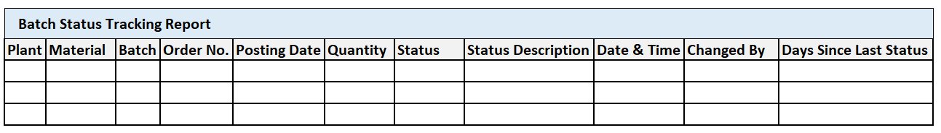
Plant = MSEG – WERKS (Plant = ‘1307’)
Material = MCH1 – MATNR
Batch = MCH1 – CHARG
Order No = MSEG – AUFNR
Posting Date = MSEG- BUDAT
Quantity = MSEG-MENGE
Status = CDPOS-VALUE_NEW
Status Description = QPCT- KURZTEXT
Date & Time = Concatenate (CDHDR- UDATE, “ “,CDHDR-UTIME)
Changed By = CDHDR- USERNAME
Day since Last Status = Difference between current and previous change date & time.

Output Medium: ALV Grid Report
Validation & Error Handling:
- Mandatory Fields : Material Number , Batch
- Error Message if No records are found?
- Validate if batch exists in MCH1
Testing Data In QAS:
Plant: 1307
Material: PL_MA01_4.75_010X1490_3500
Batches: 3423265ACE
3423316DCE
Material: PL_MA02-M_16_040X1490_3500
2424029FB0
2424228DD0

Impact: NA

Reviewed By: Mr. Saiprasad Tilleri Sir

